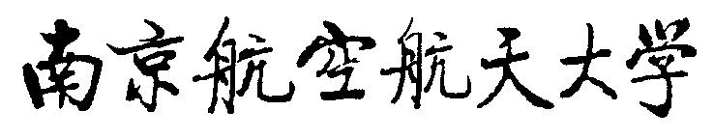
Application for Printing Official Transcript
Year Month day
Name |  | Class  No. |  | Student  No.
Major |  |  |  | Telephone
Application  Reason | You must write this Important Part.  Which language transcript do you apply? □Chinese □English  Applicant Signature:  Year Month Day
Opinion of Coordinator:

Signature:
Year Month Day
Opinion of College:

盖 章

Signature:
Year Month Day
When all procedures in the form are done, the college keeps the form for archives.

